**Lab Assignment 2C**

**Name :** Aditya Sukhdeo Dhade

**Class :** TE IT B

**Batch :** A

**Roll No.:** 37012

**Problem Statement:** Create an Angular application which will do

following actions: Register User, Login User, Show User Data on Profile Component

**Output:**

**Login page:**

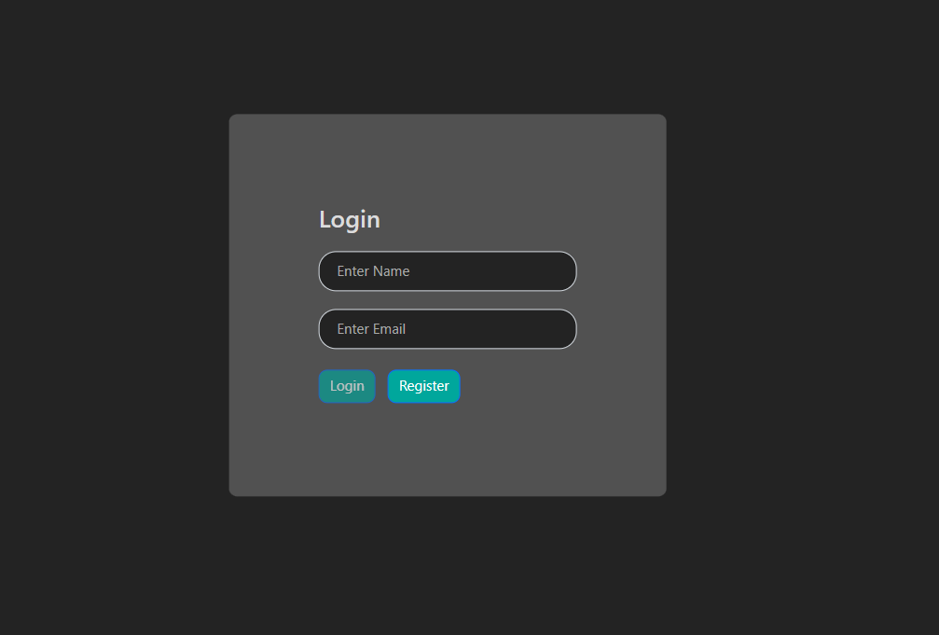

**Register Page:**

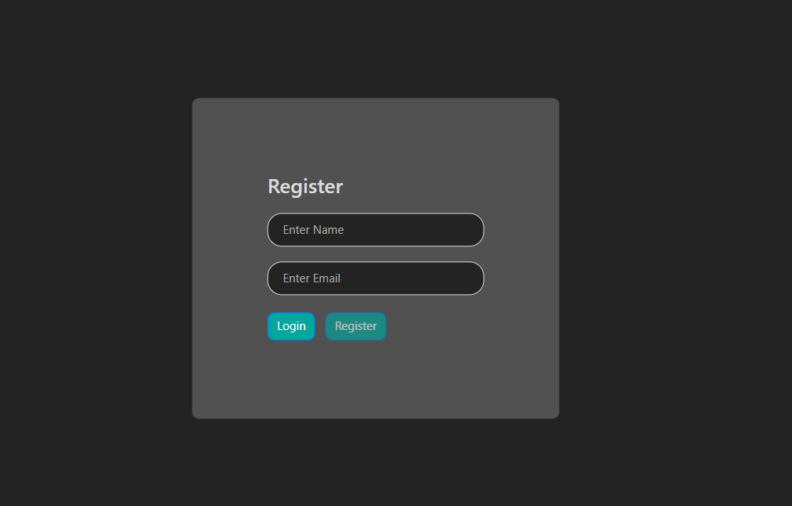

**Home page:**

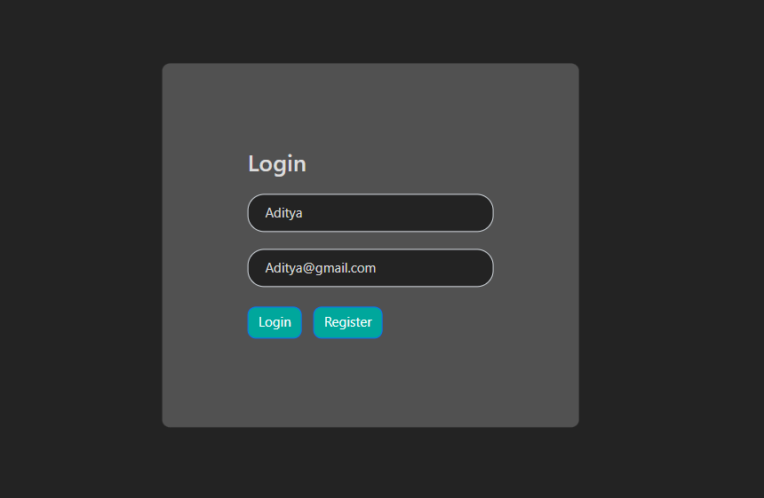

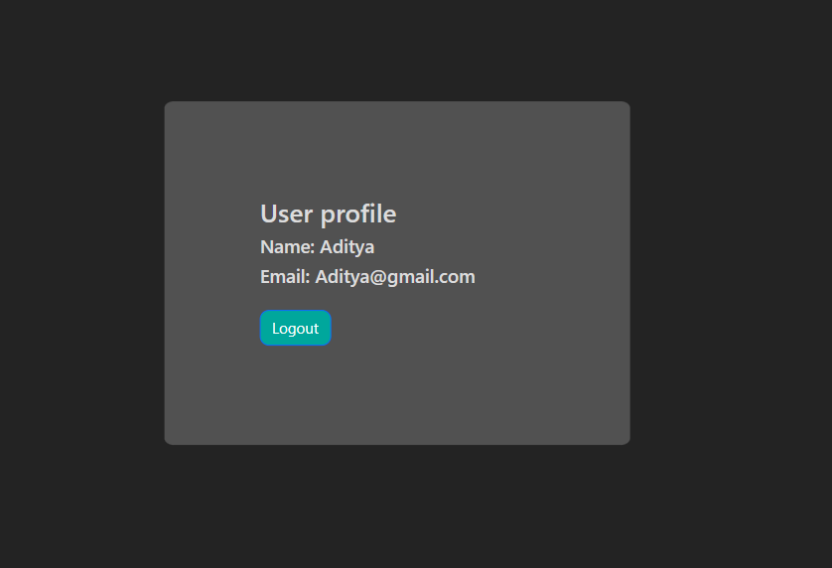

**Local Storage:**

